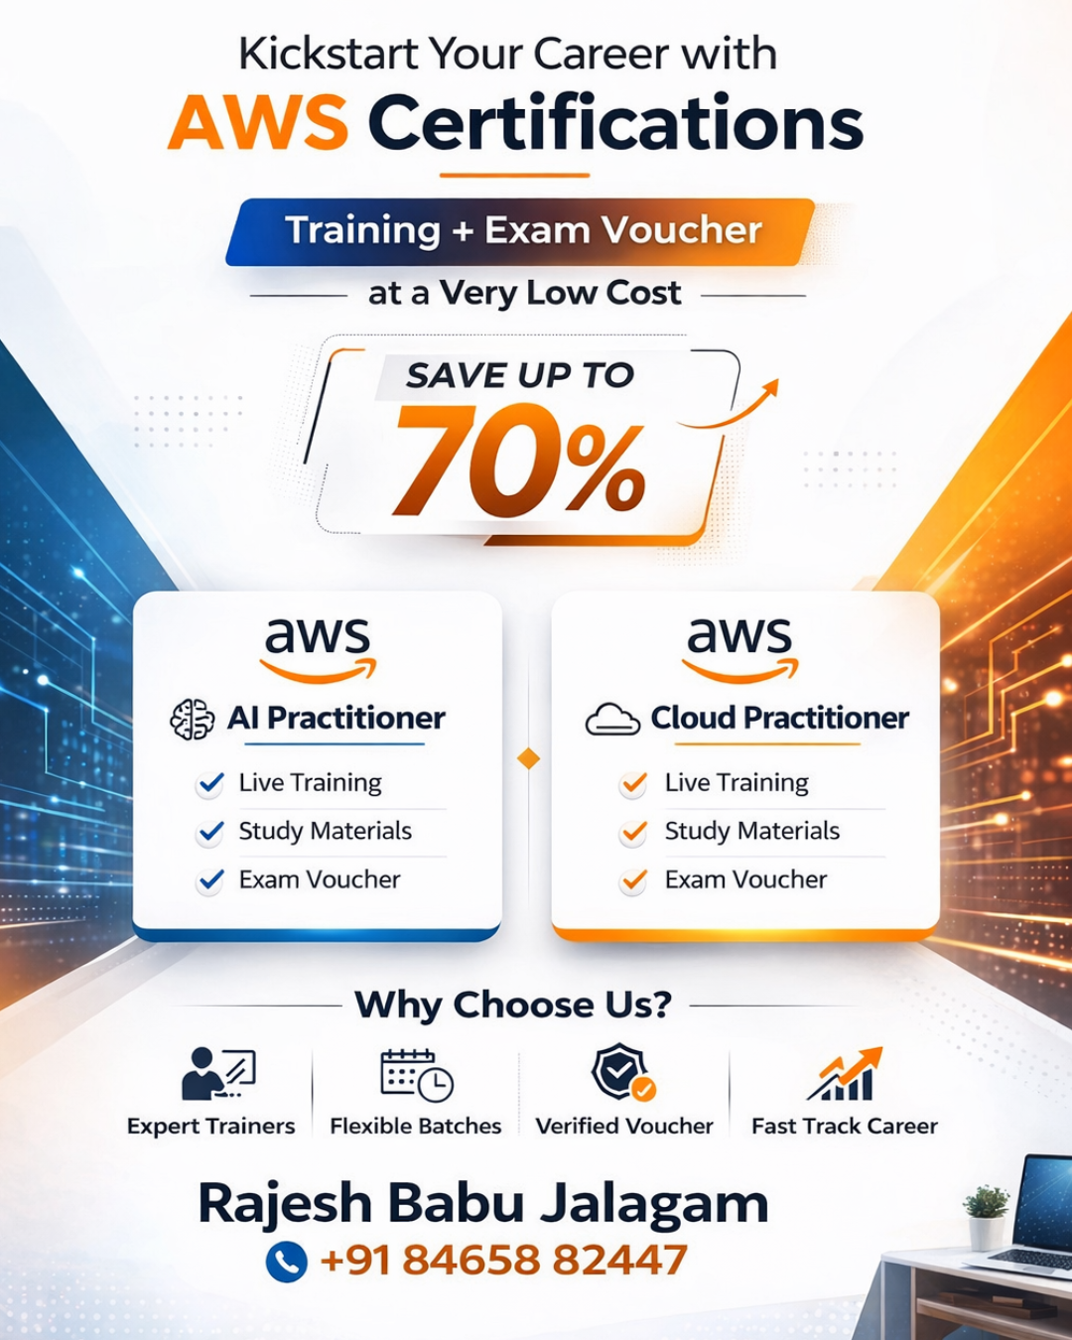

One-Day Cloud Computing Workshop + Certification Voucher.

(Industry-Oriented & Hands-On)

Objective
To introduce college students to Cloud Computing and help them understand how real-world applications are built, deployed, and managed using cloud platforms, with a focus on practical exposure and industry relevance and earn a AWS certification through a provided voucher.

Target Audience
- 2nd, 3rd, and Final Year students
- Branches: CSE, IT, ECE (Beginners-friendly)
- No prior cloud knowledge required

Why Cloud Computing is Important for College Students
- Most modern applications (websites, mobile apps, OTT platforms, online exams) run on cloud infrastructure
- Cloud skills help students bridge the gap between academic theory and real-world industry requirements
- Cloud computing forms the foundation for careers in DevOps, Data Science, AI/ML, and Cybersecurity
- Early exposure to cloud technologies improves student employability and placement readiness
- Understanding cloud concepts helps students adapt quickly to current and future IT trends

Workshop Duration
- Full Day: 5 to 6 Hours

Workshop Highlights
- Industry-oriented approach
- Live demonstrations
- Practical understanding over theory
- Interactive Q&A session

Outcome for Students
By the end of the workshop, students will:
- Understand core cloud computing concepts
- Gain exposure to real-world cloud usage
- Get clarity on cloud and DevOps career paths
- Build confidence to start learning cloud technologies

Trainer Profile (Brief)
- 12+ years of IT industry experience
- 6+ years of experience in Cloud & DevOps
- Actively involved in training students and professionals

This workshop is designed to bridge the gap between academic learning and industry requirements

Workshop Structure & Topics
Day 1 –
Module 1: Cloud & AWS Foundations
What is Cloud Computing
Benefits of AWS Cloud
AWS Global Infrastructure
AWS Shared Responsibility Model
Cloud Concepts Real-Life Use Cases
Module 2: Compute in the Cloud
Introduction to Amazon EC2
EC2 Instance Types
Provisioning AWS Resources
Launching EC2 Instances (Demo)
Amazon EC2 Pricing
Auto Scaling
Elastic Load Balancing
Messaging and Queuing
Day 2 –
Module 3: Modern Compute Services
Introduction to Serverless Computing
AWS Lambda
Containers and Orchestration
Additional Compute Services
Module 4: AWS Global Infrastructure
AWS Regions and Availability Zones
Choosing AWS Regions
Global Infrastructure Deep Dive
Infrastructure and Automation
Day 3 –
Module 5: Networking
Networking Basics
Organizing AWS Resources
Connecting to AWS Cloud
Subnets, Security Groups and Network ACLs
Amazon VPC Demo
Global Networking
Real-Life Network Architectures
Module 6: Storage Services
Block Storage (EBS, Instance Store)
EBS Data Lifecycle
Object Storage (Amazon S3)
S3 Storage Classes and Lifecycle
File Storage (EFS, FSx)
AWS Storage Gateway
AWS Elastic Disaster Recovery
Comparing Storage Services
Day 4 –
Module 7: Databases
Relational Databases
No SQL Databases
AWS Databases Demonstration
In-Memory Caching Services
Additional Database Services
Module 8: AI/ML & Analytics
AI and ML Fundamentals
AI/ML Services on AWS
AWS AI/ML Solutions
Generative AI Concepts
AWS Generative AI Solutions
Data Analytics Fundamentals
Data Pipelines on AWS
Real-Life AI/Analytics Use Cases
Day 5 –
Module 9: AWS Security
Security Fundamentals in AWS
AWS Shared Responsibility Model
Identity and Access Management (IAM) – Users, Groups, Roles
Multi-Factor Authentication (MFA)
Preventing Unauthorized Access using IAM Policies
Network and Application Protection
Security Groups and Network ACLs
Data Protection Methods (Encryption at Rest and In Transit)
Overview of AWS Security Services (AWS Shield, AWS WAF)
Module 10: Monitoring & Governance
Importance of Monitoring AWS Resources
Amazon CloudWatch (Metrics, Logs, and Alarms)
AWS CloudTrail (Tracking API Activity)
Compliance and Governance Concepts
Auditing AWS Resources
AWS Organizations Overview
AWS Health Dashboard
AWS Trusted Advisor (Security, Cost, Performance Checks)
Day 6 –
Module 11: Pricing & Support
AWS Pricing Concepts
AWS Pricing Models (On-Demand, Reserved Instances, Spot Instances)
AWS Billing Dashboard
AWS Cost Management Tools
AWS Support Plans Overview
AWS Marketplace and AWS Partner Network
Cost Optimization Best Practices
Module 12: Migration
Introduction to Cloud Migration
AWS Cloud Adoption Framework (CAF)
Seven Migration Strategies (7R Strategy Overview)
Migration Services and Tools in AWS
Database Migration Concepts
Data Transfer Methods (Online vs Offline)
Module 13: AWS Well-Architected Framework
Introduction to AWS Well-Architected Framework
AWS Specialized Services Overview
Five Pillars of Well-Architected Framework
AWS Specialized Services
AWS Well-Architected Framework
Five Pillars Overview
Architecture Best Practices
Real-Life Specialized Use Cases
.

